Members: Nguyễn An Phúc – 21IT639
Trương Văn Khải – 21IT417
Trần Vũ Lập Thi – 21IT448
Nguyễn Hữu Khánh – 21IT083

CREATE A NODEJS AND DEPLOY TO

HEROKU
- STEP 1: CREATE PACKAGE.JSON FILE
Create a new folder and open that folder in terminal
Open terminal and type: npm init
Keep hitting Enter to accept all default values
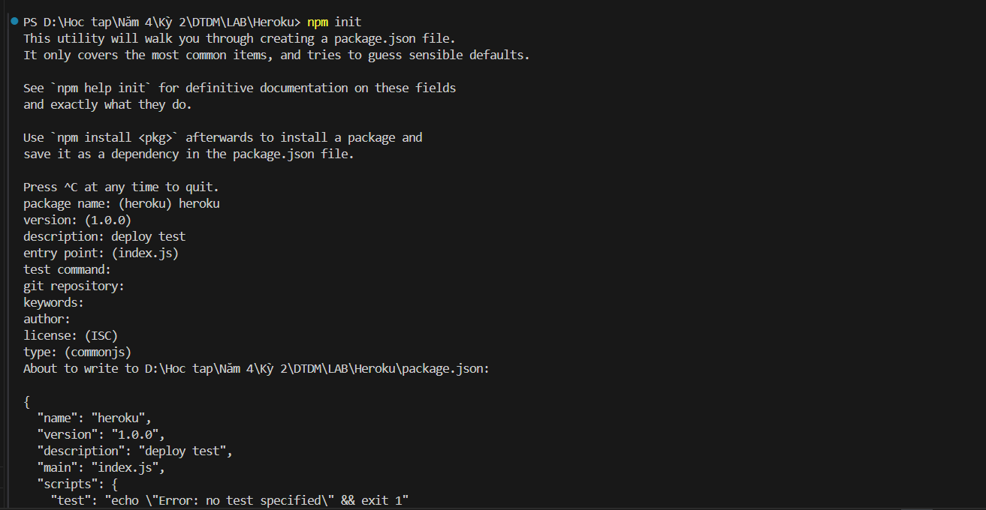
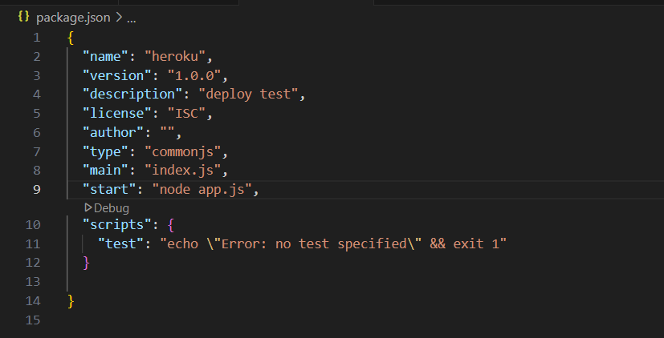
- STEP 2. ADD A FILE, APP.JS, AND PASTE THE BELOW CODE

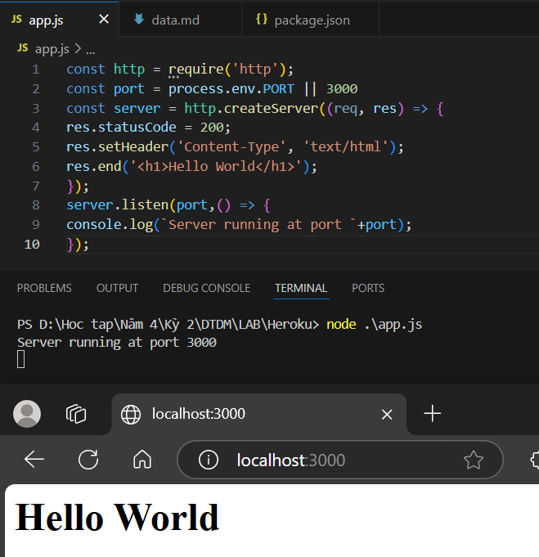

- STEP 3: PUSH TO GITHUB
